**Interface Metal touch Sensor with Arduino**

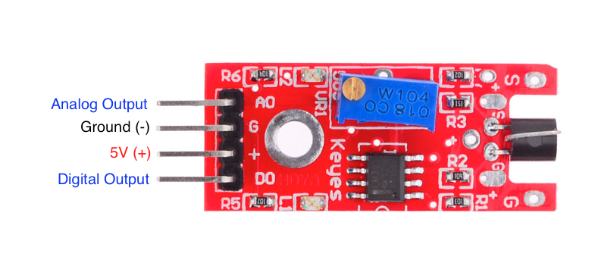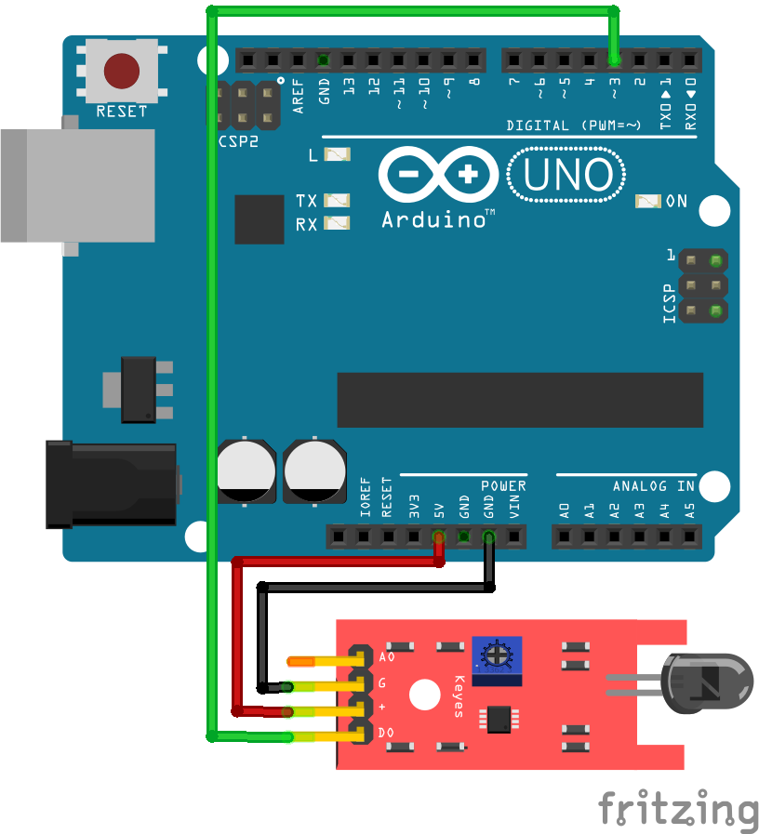

* **Metal Touch Sensor Module x 1**
* **Breadboard x**
* **Arduino UNO Board x 1**
* **Jumper Wires**

|  |
| --- |
| InLed = 11 ; |
|  | int sensorpin = 8; |
|  | int analogout = A0; //We are working with digital pins so there is no need for analog. |
|  |  |
|  | void setup () |
|  | { |
|  | pinMode (Led, OUTPUT) ; |
|  | pinMode (sensorpin, INPUT) ; |
|  | } |
|  |  |
|  | void loop () |
|  | { |
|  | val = digitalRead (sensorpin) ; |
|  | if (val == HIGH) |
|  | { |
|  | digitalWrite (Led, HIGH); |
|  | } |
|  | else |
|  | { |
|  | digitalWrite (Led, LOW); |
|  | } |
|  | } |